诚信应考,考试作弊将带来严重后果！
_____________ ________
…

姓名 学号
学院 专业 座位号
( 密 封 线 内 不 答 题 )
……………………………………………………密………………………………………………封………………………………………线……………………………………线………………………………………

华南理工大学期末考试（1）
《Compiler Construction Principles and Practice》试卷(A)
注意事项：1. 考前请将密封线内各项信息填写清楚；
2. 所有答案请直接答在试卷上；
3．考试形式：闭卷；
4. 本试卷共 六 大题，满分100分， 考试时间120分钟。
题 号 | 一 | 二 | 三 | 四 | 五 | 六 | 总分
得 分
评卷人

1. [10 pts.] The phases of a complier are described in the following figure. Please give the meanings of A, B, C, D, E in the figure.
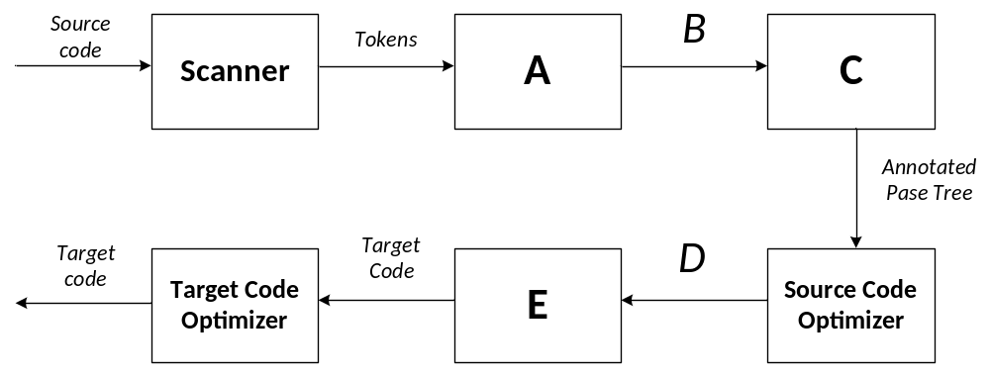 A:语法分析器
B:语法树
C:语义分析器
D:中间表达形式
E:代码生成器

2. [20 pts.] Answer the following questions.
- [5 pts.] Please write the regular definitions for all strings of a’s and b’s which do not begin and end with b.
- [5 pts.] Consider the following grammar:
A → A or B | B
B → B and C | C
C → not C | ( A ) | t | f
Write a leftmost derivation for the string:
f or ( not t and f )

- [5 pts.] Consider the attribute grammar, where h is the attribute of S and L
S→(L) {S.h=L.h×2}
S→a {S.h=1}
L→L(1), S {L.h=L(1).h+S.h}
L→S {L.h=S.h}
Draw the dependency graph for string (a,a). What’s final value of S.h for string (a,a)
- [5 pts.] Given grammar G[E]:
S→ 0 S 1|0 1
Write out the handle of the right sentential form 00S11

3. [20 pts.] Construct minimum-state DFA for the following regular expression: (a*|b*)*, which includes：
- [5 pts.] Convert the regular express into NFA first
- [8 pts
- .] Convert the NFA into DFA by subset construction. The Transition table is required.
- [7 pts.] Minimize the state of DFA

4. [10 pts.] Give three-address code corresponding to the following For-statement of C++ language:
for (i = 0; i<10; i++)
x = x+1;
这里

5. [20 pts.] Consider the following grammar G[S

]:
S→ i | ( E )
E→ E+S | E-S | S
- [5 pts.] Please rewrite this grammar to eliminate left recursion.
- [10 pts.] Compute FIRST and FOLLOW for the grammar. Please explain the rewritten grammar is LL(1) grammar or not.
- [5 pts.] Construct the parsing table

6. [20pts.] Consider the following grammar G[S]:
A→Ab|bBa
B→aAc|a|aAb
- [8pts.] Construct the DFA of LR(0) items for this grammar
- [6pts.] Is this grammar the LR(0) or SLR(1) grammar ? Give your reason. If so, Construct the parsing table.
- [6pts.] Show the parsing stack and the action of the parser for the input string aabcb.

